A Research Proposal On

**Intersection of Iot and Blockchain Technology**

Submitted in Partial Fulfillment of the Requirements for the Degree B**achelor of Engineering in Software Engineering** under Pokhara University, Nepal

Submitted By

Astha Thapa, 221707

Under the supervision of

Mr. Ashim Khadka

Date: 24 July 2024

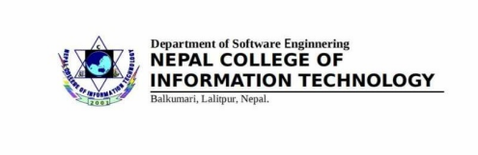

Content

**1. Introduction 3**

**1.1 Background of the study........................................................….3**

**1.2 Significance of the study............................................................4**

**2.Literature Review………………………………………………………………………….4-5**

**3.Statement of the problem............................................................5-6**

**4.Purpose of the study.........................................................………………6**

**5. Scope of the study....…...............................................................….6-7**

**6.Methodology ....................................................................................7**

**6.1 Source of data and its use...................................................….7-8**

**6.2 Theoretical and Methodological Techniques.………..………..……...8**

**6.3 Tools and Technology Involved..............................….................9**

**6.4 Block Diagrams........................................................................10**

**6.4.1 Use case Diagram......................................................10**

**6.4.2 Activity Diagram..........…......................................10-11**

**6.4.3 Class Diagram………………………………………………………….11**

**7.Expected Outcomes.........................................….......…....................12**

**8.Timeline............................................................…............................12**

**9. Reference ...................................……......................................….13-14**

**Abstract**

The Internet of Things (IoT) represents a new technology that enables both virtual and physical objects to be connected and communicate with each other, and produce new digitized services that improve our quality of life. Blockchain technology enhances IoT security threats through its decentralization, smart contracts, tamper-proof ledger, which ensures data integrity and protects against cyber-attacks.

**Introduction**

IoT refers to the interconnection of physical devices, buildings, and other items embedded with sensors, software, and network connectivity that enable these objects to collect and exchange data, which faces security threats from centralized traditional architecture. Blockchain technology offers a decentralized and secure framework for IoT, addressing core challenges such as cybersecurity, scalability, and trust.

Background of the study

The Internet of Things (IoT) connects people, places, and products, and in so doing, it offers opportunities for value creation and capture. Blockchain is a decentralized digital ledger technology that enables secure and transparent transactions between parties without intermediaries. Blockchain empowers the IoT devices to enhance security and bring transparency in IoT ecosystems.

Significance of the study

Integrating IoT and blockchain technologies can revolutionize various industries by enabling secure, transparent, and efficient data exchange. Blockchain offers a scalable and decentralized environment to IoT devices, platforms, and applications. Every device around us is now equipped with sensors, sending data to the cloud. Therefore, combining these two technologies can make the systems efficient.

**Literature Review**

IoT and blockchain are two emerging technologies that have gained significant attention due to their potential to transform various industries [1]. IoT refers to the interconnection of physical devices, buildings, and other items embedded with sensors, software, and network connectivity that enable these objects to collect and exchange data. The data collected by these device improve the efficiency and performance of various systems, including transportation, healthcare, energy, and manufacturing [ 2].

On the other hand, blockchain is a distributed digital ledger that enables secure and transparent transactions between parties without intermediaries [[3], [4], [5]]. The technology is built on a network of tamper-proof nodes that validate and store data securely and, making it ideal for managing and sharing sensitive information.

Integrating these two technologies can create secure and scalable IoT networks that can streamline data exchange between devices, systems, and stakeholders. The combination of IoT and blockchain can be beneficial in applications that require a high level of security, such as financial transactions, SCM, and healthcare [6].

**Statement of the problem**

The rapid growth of Internet of Things (IoT) devices has led to an exponential increase in data generation and connectivity across various sectors. However, the traditional centralized architecture of IoT systems faces significant challenges in terms of scalability, security, and data integrity. Centralized systems are vulnerable to single points of failure, cyber-attacks, and data breaches, which compromise the security and reliability of IoT networks.

**Purpose of the study**

IoT devices, which collect and share vast amounts of data, face challenges related to security, scalability, and data integrity. By application of blockchain technology i.e decentralization , immutable ledger, and the automation provided by smart contracts, it aim to enhance the security and efficiency of IoT centralized architecture.

**Scope of the study**

This study focuses on exploring how blockchain technology can enhance the Internet of Things (IoT). It aims to address challenges such as security risk, scalability issues, and data integrity concerns within current IoT systems. For Iot, the scalability of the centralized architecture is another problem, which may not be a practical solution for the IoT system that increases in billions every year [7].

Blockchain's ability to provide a tamper-proof record and execute transactions via smart contracts without intermediaries can simplify process and reduce costs. By examining real-world applications and case studies, and through integrating blockchain with IoT can lead to more efficient and transparent operations

IoT (Internet of Things) and blockchain technology together benefit educational institutes , business sectors ,consumers ,government and general overall civilian who uses IoT services. IoT services ensure safer interactions promoting smarter cities reliable healthcare systems all through decentralized databases and smart contracts delivered by blockchain technology.

**Methodology**

**Source of data and its use**

In this study, Primary sources include IoT device logs, blockchain transaction records, and smart contract executions. Secondary sources will consist of academic journals, industry reports, and case studies on IoT and blockchain integration.

Firstly, IoT device logs will be analyzed to provide real-time data on device interactions, performance metrics, and potential security incidents. By examining these logs, we can identify patterns and anomalies that highlight the strengths and weaknesses of current IoT implementations. Secondly, blockchain transaction records offer insights into the security and transparency of data transactions.

**Theoretical and methodological techniques**

The theoretical aspect of this study focuses on analyzing existing IoT frameworks and architectures. IoT networks will be simulated to model interactions among devices and evaluate system performance. Tools such as NS3 (Network Simulator 3) and OMNet++ will be utilized for Simulator 3) and OMNet++ will be utilized for these simulations.

Blockchain platforms, including Ethereum and Hyperledger Fabric, will be modeled to assess their suitability for IoT applications. These platforms will be simulated to test their scalability, transaction throughput, latency, and resource consumption in IoT environments.

**Tools and Technologies**

The tools and technologies enable the study to evaluate and implement blockchain solutions that enhance security, scalability, and efficiency in IoT network.

1. **Simulation and Modeling:**

* **NS3 (Network Simulator 3):** For simulating IoT network behaviors and performance metrics.
* **OMNet++:** Another tool for simulating complex communication systems in IoT environments.

1. **Modeling Blockchain Platforms:**

* **Ethereum:** Known for smart contract functionality and decentralized applications (DApps).
* **Hyperledger Fabric:** Designed for enterprise use, emphasizing scalability and privacy in IoT data management.

1. **Python:** Used for data mining, analysis, and visualization tasks.
2. **Solidity:** Programming language for developing smart contracts on Ethereum.
3. **Truffle Suite:** Development environment for deploying and testing smart contracts.
4. **Cloud Services (AWS or Azure):** Provides scalability and security for hosting blockchain nodes and IoT data storage.

**BLOCK DIAGRAM**

Use case diagram

Use-case diagrams describe the high-level functions and scope of a system. These diagrams also identify the interactions between the system and its actors.

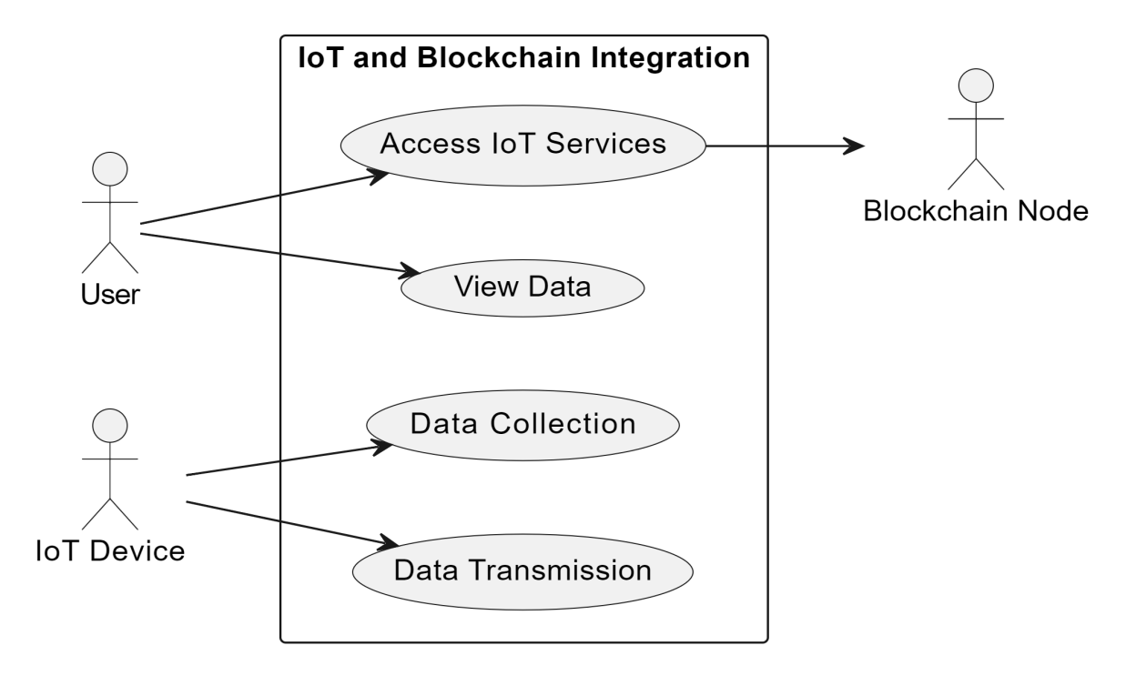

Activity diagram

Activity Diagrams are used to illustrate the flow of control in a system and refer to the steps involved in the execution of a use case.

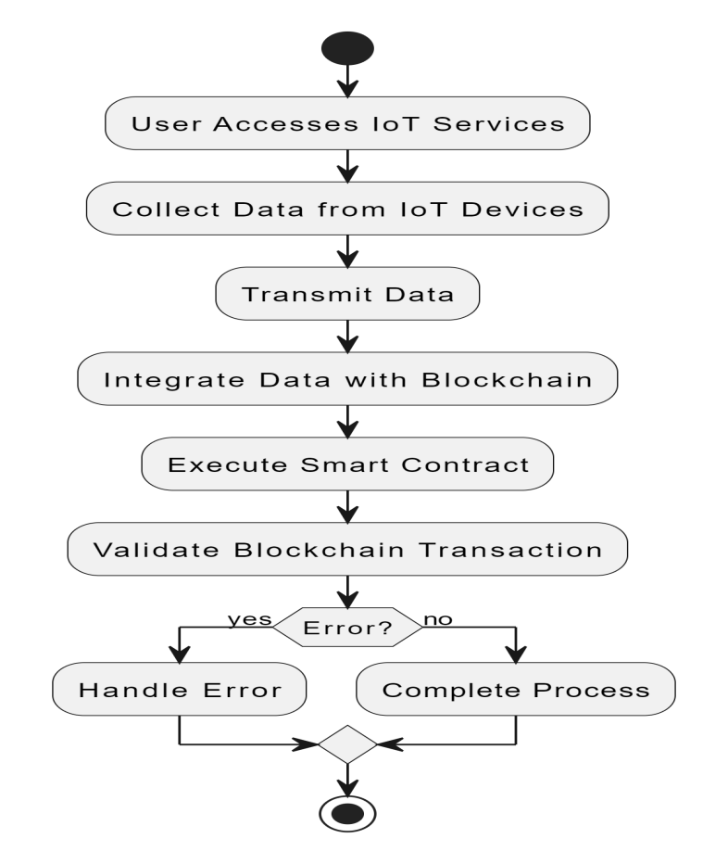

Class diagram

A class diagram is a type of static structure diagram in UML (Unified Modeling Language) that describes the structure of a system and the relationships among objects.

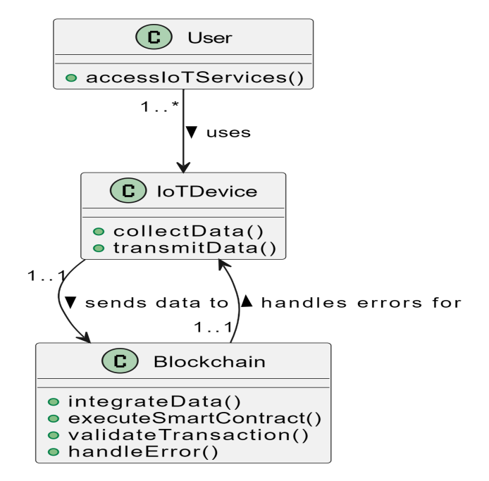

**Conclusion**

From integrating IoT and blockchain technologies it is more secure, efficient, and transparent system for data exchange and management. Moreover, blockchain delivers better security and data integrity through tamper-proof and immutability features. The integration of blockchain with IoT can resolve issues of the IoT centralized system and provides a good way for future developments. Therefore, this paper provides a comprehensive discussion of integrating the IoT system with blockchain technology.

Timeline

| **Task** | **Duration** | **Start Date** | **End Date** |
| --- | --- | --- | --- |
| Literature Review | 2 weeks | 16 July 2024 | 30 July 2024 |
| Data Collection and Analysis | 3 weeks | 1 August 2024 | 21 August 2024 |
| Theoretical and Methodological Techniques | 4 weeks | 22 August 2024 | 18 September 2024 |
| Simulation and Modeling | 3 weeks | 19 September 2024 | 9 October 2024 |
| Development and Testing of Smart Contracts | 4 weeks | 10 October 2024 | 6 November 2024 |
| Integration and Evaluation | 3 weeks | 7 November 2024 | 27 November 2024 |
| Final Report Writing and Submission | 2 weeks | 28 November 2024 | 12 December 2024 |

References

1. A. Ahi, A.V. Singh, Role of distributed ledger technology (DLT) to enhance resiliency in internet of things (IoT) ecosystem, *Amity International Conference on Artificial Intelligence (AICAI)*, IEEE (2019).

[2] S. Zhao, S. Li, Blockchain enabled industrial Internet of Things technology, I*EEE Transact. Comput. Soci. Syst.*, (2019).

[3] A. Rejeb, S. Simske, Internet of Things research in supply chain management and logistics: a bibliometric analysis, 2020.

[4] M. Wu, K. Wang, A comprehensive survey of blockchain: from theory to IoT applications and beyond IEEE Internet Things J., *mity International Conference on Artificial Intelligence (AICAI),* 2019.

[5] F. Elghaish, M.R. Hosseini, Blockchain and the ‘Internet of Things' for the construction industry: research trends and opportunities,2021

[6] S.N. Khan, F. Loukil, C. Ghedira-Guegan, et al.

Blockchain smart contracts: applications, challenges, and future trends Peer-to-peer Network. Appl., 2021

[7] Fernandez-Carames, T.M.; Fraga-Lamas, P. A Review on the Use of Blockchain for the Internet of Things, *IEEE Access,* 2018